Idea on Phase Empathize & Discover

|  |  |
| --- | --- |
| Date | 1 July 2025 |
| LTVIP2025TMID59793 | LTVIP2025TMID44259 |
| Project Name | Pattern Sense: Classifying Fabric Patterns using Deep Learning |
| Maximum Marks | 4 Marks |

Empathy Map Canvas:

An empathy map is a simple, easy-to-digest visual that captures knowledge about a user’s behaviours and a tudes.

It is a useful tool to helps teams be er understand their users.

Crea ng an effec ve solu on requires understanding the true problem and the person who is experiencing it. The exercise of crea ng the map helps par cipants consider things from the user’s perspec ve along with his or her goals and challenges.

EMPATHY MAP CANVAS: Pattern Sense: Classifying Fabric Patterns using Deep

Learning

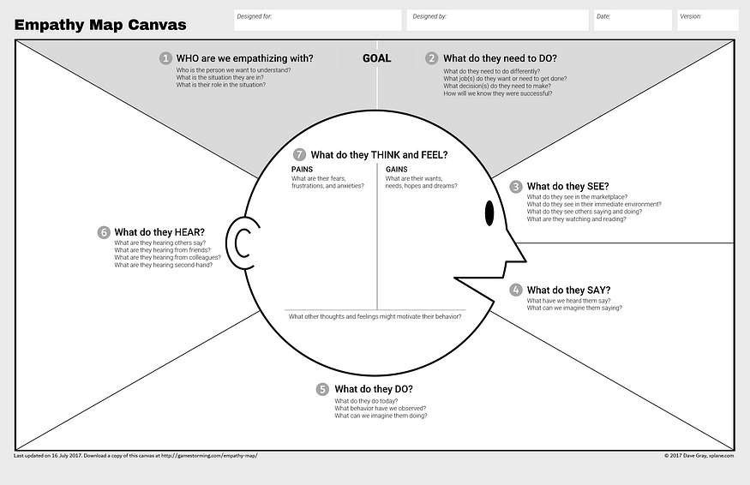

Reference: h ps://www.mural.co/templates/empathy-map-canvas